**University of Petroleum and Energy Studies**

School of Computer Science

Department of Cybernetics



**Graphics & Animation Tools**

**LAB FILE**

**(Session: 2020-2021)**

Course: B. Tech with Specialization in Open Source and Open Standards

Batch: 2017-2021

Semester: VIIth

**Submitted By: -**

Nikhil Mishra

Roll No: R100217043

SAP ID: 500062584

**Submitted To: -**

Dr. Durgansh Sharma Assistant Professor

Department of Cybernetics

**Experiment- 10** Design of Building using Blender.

In this experiment we need to create a 3D Model of a Building with the help of blender.

1. Create a new project and start with scaling the default cube to look like a cuboid (main structure of the building).
2. Click on the add button and add another cube. Scale this cube according to the size of the base cube. This cube will be used for making the boundary on the top of the building (to represent the side of the roof).
3. Copy the cube and adjust these cubes on 2 sides of the base cube.
4. Now, similarly make 2 cubes to represent the other 2 sides of the roof.
5. Now, take a plane and scale it and position it on one of the sides of the base cube (to represent windows).
6. Add the plane representing windows as per the size of the base cube.
7. Now, make another plane and scale and fix it at the bottom of the base cube representing the door of the building.
8. Fill colours in all the shapes as per your choice.

**OUTPUT:**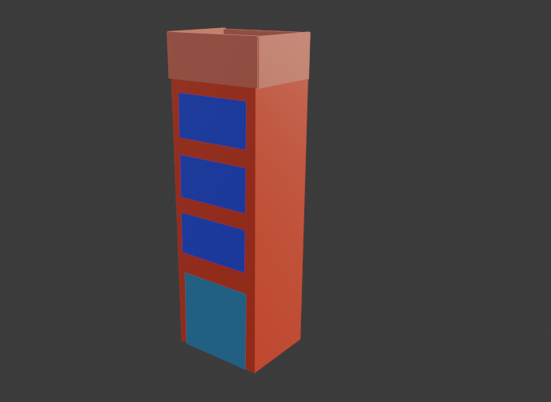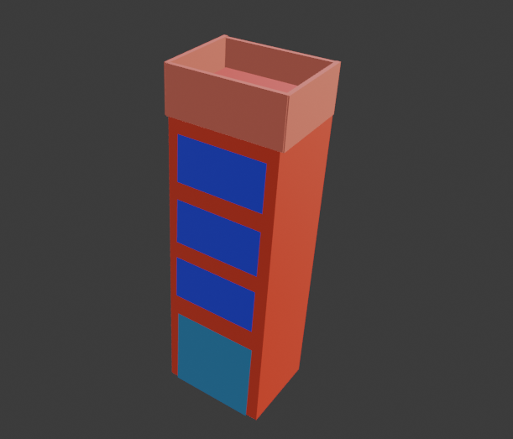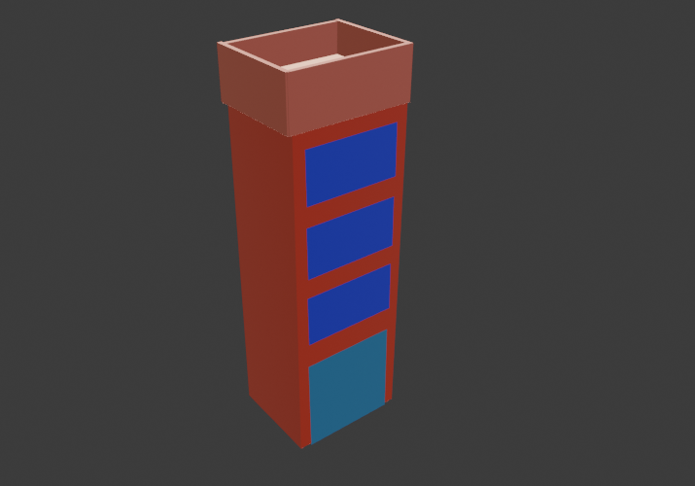

**Google Drive Link:** [**https://drive.google.com/drive/folders/18C0VtIAk-awUy3Axst3degZLR7YdXza2?usp=sharing**](https://drive.google.com/drive/folders/18C0VtIAk-awUy3Axst3degZLR7YdXza2?usp=sharing)